Programming Assignment 3.2

**Assignment Description**

You want to develop a program that takes in as many positive integers as the user wants to enter and then tells them how many integers they entered and the mean (average) of those numbers. This will also give you more practice implementing while loops!

In this assignment, you'll get integer numbers until you get a -1, at which point you’ll print how many numbers you processed (not including the -1) and the mean of those numbers (not including the -1).

**Getting Started**

Download the appropriate zip file for your OS below and unzip the file somewhere on your computer.

**Windows Programming Assignment 3.2 Materials** ZIP File

**Mac Programming Assignment 3.2 Materials** ZIP File

Open the project in Visual Studio.

**Important:** You MUST only add code as indicated by the comments in that file. If you don't, you're virtually guaranteed to fail all the test cases in the automated grader.

**Requirements**

The code I’ve provided in the Program.cs file reads in a set of integers that ends with -1. Your code must call the **GetValue** method and store the **int** the method returns in a variable, then process that number as appropriate.

Your solution must print the following on a single line:

* The count of the numbers you processed (not including the -1)
* A space
* The mean of the numbers you processed (not including the -1)

For example, if the set of numbers you process is 1 2 3 4 -1, your output should be the following on a single line:

**4 2.5**

We’d typically label our output to tell the user what the output means, but that will just confuse the automated grader. You must print ONLY the values described above in your output, with the values appearing on a single line with a single space between them.

Note: For the special case when -1 is the first number, your count and mean should both be set to 0.

**Running Your Code**

Because of the code I included to work with the automated grader on Coursera, when you run your program the command prompt window will open and it will sit there doing nothing. To make your code run, type in a set of integers, ending with -1, with a space between each integer, and press the <Enter> key; your code should then run so you can check your output. For example, your input could be:

**1 2 3 4 -1**

You can actually run your code again if you want to by typing in a set of integers, ending with -1, with a space between each integer, and pressing the <Enter> key again. When you’re ready to stop running your code, type q (for quit).

Here's what running the code multiple times with different inputs should look like (remember, you're including a newline at the end of each of your output lines). The first line is the integer input, the second line is your output line, and so on:

**1 2 3 4 -1**

**4 2.5**

**-2 0 -1**

**2 -1**

**q**

**Important Note:** The Coursera formatting makes it look like there's a blank line between each of the lines above, but there's not. The above output should be exactly 5 lines of output.

The image below shows my console window when I run the code multiple times as described above:

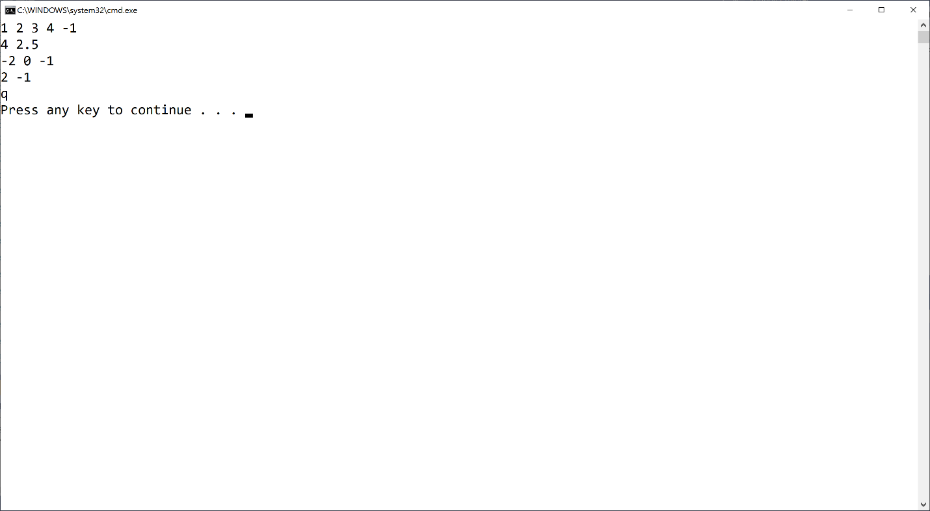

If your output doesn't match the image above EXACTLY (no extra words, characters, spaces, or blank lines) you'll fail all the test cases in the automated grader.

Mac users: You may have an extra blank line or no blank line after the q. That's fine.

**Test Case Inputs**

The automated grader uses the following set of test case inputs to test your code (1 test case per line):

**1 2 3 4 -1**

**-1**

**-2 0 -1**

**1 1 1 1 1 -1**

**2 1 0 1 2 -1**

**-1**

**-2 -3 -4 -1**

**-2 0 2 -1**

**5 5 5 5 5 5 5 5 5 1 -1**

**1 1 1 1 1 1 1 1 1 1 1 1 1 1 1 1 1 1 1 0 -1**

You should figure out what the expected results are for each test case input and make sure your code is generating those expected results in the required format before submitting your code for grading.

**Common Problems**

Historically, a number of people post about grading errors on this assignment (because their code is wrong). Here are a couple things you should check:

1. You have to start with the Visual Studio project I gave you in the assignment materials and add your code in the section indicated. The code I gave you includes the appropriate structure for the automated grader to work. If you don't do this, you'll almost definitely fail all the test cases in the automated grader
2. I give you an example in this assignment (and all assignments) for what output you should get when you run the code multiple times. Be sure to try that example; if your code doesn't generate output exactly as shown in the example, your code isn't working properly

**Submitting Your Solution**

Go to the LMS and submit your project to **Assignment 3.2**.